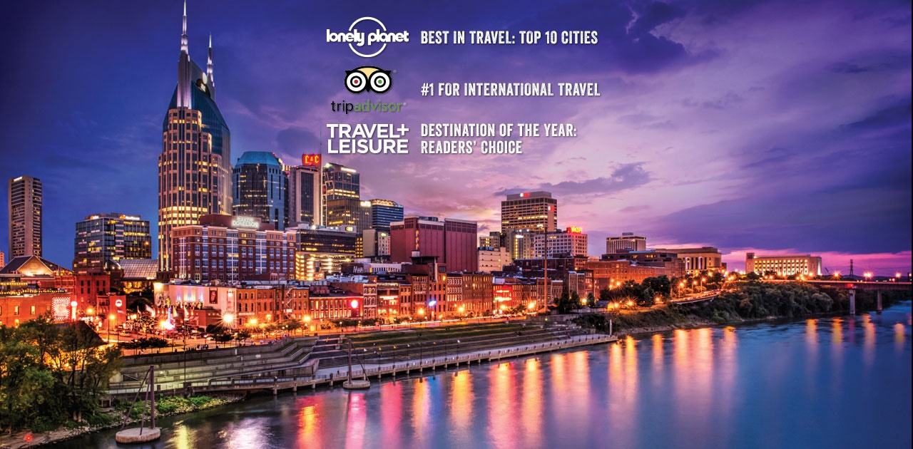

Nashville and Memphis
Nashville 5 nights, 1 full day trip to Memphis- Thursday May 26th to Tuesday June 1st- $3150 (includes rt airfare, 5 nights’ accommodation at 4-star diamond rated hotel, all included tours, lunch and dinner)
Deduct $250 if not going on Memphis Day Trip ($2900)
Nashville Friday to Monday- Please call for information if interested in just joining us for the weekend.
This is a glimpse of what we are putting together. Some things are subject to change, be added to, or disappear (though we don’t think anything on here will do that)
- An all-encompassing 4-hour “Discover Nashville” van tour where we get a glimpse of sites such as Bicentennial Capitol State Park, Vanderbilt University, The Parthenon-which is why Nashville is called
‘The Athens of the South’ - a full-scale replica of the Parthenon in, Tennessee State Capitol, Riverfront Park, Music Row and, Honky Tonk Row, Fort Nashborough and all of Downtown Nashville. After the narrated portion of the tour has finished, we take a personal tour of the Ryman Auditorium, Studio B and a self-guided tour the Country Music Hall of Fame and Museum.
- Backstage dressing room guided tour of the Grand Ole Opry and Gaylord Opryland Resort. Enjoy a tour of the beautiful Opry House and get a behind-the-scenes, look at country’s most famous show. Hear the stories that make up the history and stand in the very circle where the brightest and best of Country Music play. Then visit the Gaylord Opryland Resort and enjoy a guided tour of the incredible nine-acre resort with beautiful lush indoor gardens and waterfalls. This also includes a ride on a Delta Flatboat down the indoor river that navigates through this truly amazing resort.
- Friday Night- Tickets to Grand Ole Opry (must RSVP enough in advance to guarantee). For more than 90 years the greatest country music stars in the world grace the Opry stage for its terrific show. There are always surprises and you never know when famous members like Garth Brooks, Dolly Parton, Brad Paisley, and Dierks Bentley may be stopping by.
- Visit the Belle Meade Plantation-As the premier thoroughbred racing and breeding farm in the South for over a century, The Belle Meade Plantation was THE center of hospitality in the 1800s. Five United States presidents have enjoyed the renowned hospitality of the Harding and Jackson families, and the 5,400 acres that made up the Plantation were home to some of the greatest horses in racing history. As groups wander the mansion and cross the grounds, guides divulge facts about famous visitors, such as President Cleveland and General Ulysses S. Grant including a guided tour through the plantation’s beautiful Greek-Revival mansion commissioned by John Harding in 1845. After the tour of the house and grounds, we will have a wine tasting at the Plantation winery. We will also enjoy the Southern-style cuisine at the Harding House restaurant located on the plantation grounds.
- The Hermitage The home of President Andrew Jackson, the seventh President of the United States. Considered to be the most authentic early presidential home in the nation, the Hermitage consists of the Jackson family mansion, garden, slave quarters, and the original log cabin the family occupied in 1804. Historians consider President Jackson’s Hermitage the best preserved early presidential home. Explore its quarters just as President Jackson and his staff did back in 1836. Stroll the lovely formal gardens, then visit the slave quarters, the estate’s original 1804 cabin and the sight where this president and his wife were laid to rest. The Hermitage was once home to 150 slaves in addition to the Jackson family. A trip through the plantation grounds gives one an idea of what it would have been like to be a member of an elite family - or a slave - in the Antebellum South
- Climb aboard the General Jackson, this 300-foot-long paddle wheel riverboat, which holds the distinction of being the largest showboat in the world, will take guests past natural and historical sites along the banks of Nashville's beautiful Cumberland River. Four massive decks offer excellent opportunities to see the beautiful scenery of Nashville skyline and the stunning countryside of central Tennessee. This majestic vessel was designed to recreate the impressive showboats that cruised the waters of America’s rivers in the 19th century. Then enjoy a savory Southern-style buffet meal in the boat’s onboard Victorian theater (drinks not included). The cruise features a lively variety show called “Nashville Live.” The world-class cast includes two rising country artists, country comedy and features fiddle and guitar soloists, along with a live country band.
- We will visit the town of Franklin TN (where I owned my bar and music venue), as we step back in time to 1864 and the Civil War’s Battle of Franklin on a guided, 7-hour tour. The Battle of Franklin was one of the worst disasters of the war for the Confederate States Army, known as the five bloodiest hours of the Civil War. During the American Civil War, the Battle of Franklin was fought in the city resulting in almost 10,000 casualties. On this tour we see the bullet and cannon ball holes as well as the battle-scarred floors that still bear witness to the carnage of this dark time in history. Spend time in the landmarked historic town of Franklin to shop, eat and view its historic sites. Visit the Lotz House and Carter House, which were used in the war as field hospitals and tour the Carnton Plantation to learn about its role during the Civil War. Our southern lunch is at the famous Puckett’s Grocery-the best lunch in town!
- Optional all day trip (-$250 if opting out of this) We take a day trip from Music City to Memphis: 7am. Come experience the legendary character of Memphis, TN and see why this city is mentioned in more song lyrics than any other place on Earth. Memphis is the birthplace of Rock 'n' Roll, the capitol of Blues and home to some of the best bar-b-que. We walk in the footsteps of legends and celebrate 60 years of Rock 'n' Roll with a visit to Elvis Presley's home, Graceland. We'll see the burial site of the King of Rock 'n' Roll, walk through the Elvis car museum, and see two deluxe airplanes that he used for tours. We will have lunch at Graceland. Next, we're off to learn what accident set Rock 'n' Roll in motion at Sam Phillips' famed Sun Studios in the heart of Downtown. Take a guided tour to see what the recording process used to be like. Hear the stories of how many legends got their start here, such as Johnny Cash, Roy Orbison, Jerry Lee Lewis, and the King. See the famous Peabody ducks make their way down the red carpet from their fountain to the elevator as they head to bed at the lavish Peabody Hotel. Hear the story about why this started and how it continues today. Then take time on your own to explore Beale Street, where we dive in to some Blues before we get a BBQ dinner.
What we are working on to include- Dinner and Lunch Daily (no breakfast), Discover Nashville 4 hour Tour, Andrew Jacksons home-The Hermitage, The Belle Meade Plantation, The Country Music Hall of Fame, The Ryman Auditorium, Tickets to the Grand Ole Opry, The Gaylord Opryland Resort, Delta Boat Ride, General Jackson Showboat and live entertainment, Backstage tour of Grand Ole Opry, Tour of Franklin TN and Battle of Nashville, Memphis trip including- Graceland, Sun Studios, Beale Street and the famous Peabody ducks, BBQ in Memphis. Lunch at the famous Puckett’s, dinner at 28 rated Zagat restaurant, Etch and lots more (to be created and added to this list).
OPTIONAL Ideas if replacing Memphis- Nashville Symphony, Jack Daniels Distillery, Arrington Vineyards, Johnny Cash Museum, Art gallery inside Parthenon Tour, Frist Museum.
Why Nashville?-First off, I lived there for 5 years, so I know the city, and though things have changed since I moved back to NYC, things have only gotten better in Nashville. In 2016 Nashville was crowned "Destination of the Year" in Travel + Leisure magazine's annual Readers' Choice poll. “Receiving 15.8 percent of the votes -- nearly twice as many as second-place destination, Charleston. Music City topped the list of ALL international and domestic locations beating out international hot spots like Australia, Cuba, Greece, Iceland, Istanbul and Paris as well as fellow domestic darling, New Orleans. According to Travel + Leisure, “Nashville is a perennial tourist favorite, reveling in its ‘It-City’ status for a while now, but the Tennessee capital only gets more exciting with each year… but the real pull for travelers visiting Nashville in 2015 was the food!!!”.
“Constant restaurant openings by top chefs are solidifying Nashville’s place as THE culinary capital in the new ‘American South”. According to GQ- Nashville has “Food Worth Flying For”- The city's creative energy touches everybody - and the ingenious chefs are no exception. This is talent you can literally taste. Whether it's humble Southern fare or haute cuisine you're after- you'll find authentic Nashville flavors all over town.”
The New York Times writes, “Nashville’s farm-to-table eateries are making major waves on the foodie scene, with an infusion of creative genius-chefs moving to Tennessee’s capital to carve out a name for themselves in this emerging epicurean culture.” Eateries throughout Nashville have also received accolades also from Conde Nast- “New hotels and tours, emerging food scenes, and special events makes Nashville one of the hottest travel destinations with enterprising chefs that are now the new country-music stars, bringing refined yet unfussy restaurants to Music City. Conde Nast goes on to say, “Nashville seems to be where everyone has just been or is on their way to right now, from friends to colleagues everyone is heading out there and there's enough going on food-wise to warrant a trip solely for eating, which we and local tastemakers have been telling you about for a while. If you don't get out to Nashville soon, you might find yourself in the tragically unhip category.”- Conde Nast
Nashville is No. 5 on Forbes.com's list of cities Americans are "flocking to”, and The New York Times also lists Music City #15 on their list of “52 Places to Go”, and more impressively, one of the most “coveted international travel destinations” for foreigners. In fact, Tripadvisor listed Nashville #1 for international travel.
The Times goes on to tout Nashville’s music scene as well, “Nashville’s music scene rivals the other greats such as Austin, New Orleans, New York, Chicago, and Los Angeles.” It ranked second on Travel+Leisure’s, “America’s Favorite Cities” survey and 2nd for America’s best live music city (after New Orleans) though it ranked number one by the experts (journalists, musicians, academics, producers) in that same category.
According to Forbes, “Nashville scored highest in a Metro Music Index as a center for musicians and the music industry. Almost every venue in town offers live music: coffee shops, restaurants, bar and even the airport! Music continues to define this city's heart and soul. No doubt about it: Nashville is the center of the universe for country music fans. Just take a short walk down almost any street to see the countless clubs, bars, and restaurants made famous by country stars, past and present. And none of these venues is more legendary than the Grand Ole Opry. Everyone who's anyone has performed there.”
Business is also booming as Nashville which has the second-highest rate of young small-business owners, between ages 20 and 34. Nashville is on Business Insider's list of the 13 hottest American cities for 2016. To compile this list, they looked at job growth, population growth, affordability, livability, and the health and well-being of each city's residents. They also considered each city's "coolness" factor. “Nashville may be known for its country-music scene, but these days the southern city is much more than just a music town.
Nashville only U.S. city on Lonely Planet's high-profile Top 10 list for 2016- “If you thought Nashville was all about twanging guitars, big hair and cheatin’ hearts, well, you’d be only part right. Country is still the heart and soul of Music City, but poke your head outside the honky tonk bars of lower Broadway, and you’ll notice new sounds in the air: the grind of construction work, excited chatter at the latest restaurant or art gallery opening and, loudest of all, the energetic thrum of new business. “ The popularity of the TV show "Nashville" has helped boost tourism as Nashville hosted a record-breaking 13.1 million tourists and it continues to grow. Times are good in Nashville and the spoils are there for the taking. While crooners downtown may sing of ruin and raising hell, tastemakers are busy opening hip breweries, coffee roasters and independent fashion stores or transforming once-abandoned warehouses into creative retail space and top notch restaurants.
The new dining scene in particular is unrecognizable: while carnivores shouldn’t miss the region’s signature barbecue and ‘meat and three’, celebrated chefs and food talent are bringing a sleeker brand of eatery to town. Many new Nashville restaurants have been listed as some of the country’s finest new restaurants.

Sporting an AAA Gem rating—the Johnny Cash Museum honors the life, work, and legend of one of American music's most iconic figures. The mythology of the Man in Black comes to life through a collection of the musician's personal memorabilia, bringing guests into contact with the music and lyrics that reshaped country music for generations of fans. Curated by lifelong fan and owner Bill Miller, the collection has earned plaudits from outlets ranging from CNN and the New York Times to Billboard and Vogue, with National Geographic's placing it at the top of their list of Pitch-Perfect Museums.
Taste of Nashville Food Tour
Taste of Nashville: A Culinary Walking TourKnow you want to try the Nashville fare but not sure where to start? This is your answer!
Experience the culture, history, and flavor of Music City with an enthusiastic and experienced guide.
Take a leisurely stroll through the heart of downtown Nashville tasting a variety of specially-selected foods from 6 local restaurants and eateries.
From pralines to barbecue, explore the most popular local fare and even visit some hidden gems off-the-beaten path. Along the way, learn the history of the sites that made Nashville what it is today, including the Ryman Auditorium, Tootsie’s World-Famous Orchid Lounge, Printer’s Alley, and The District
A trip to Memphis wouldn't be complete without a duck walk. See the famous Peabody ducks make their way down the red carpet from their fountain to the elevator as they head to bed at the lavish Peabody Hotel. Hear the story about why this started and how it continues today.
Then take time on your own to explore Beale Street, where you could dive in to some Blues and bar-b-que, or take a short stroll to the Memphis Rock 'n' Soul Museum. There's plenty to do in this lively downtown scene.
We will finish the day with a drive by the Mississippi River

